UNITED STATES

SECURITIES AND EXCHANGE COMMISSION
Washington, D.C. 20549

SCHEDULE 13D

Under the Securities Exchange Act of 1934

(Amendment No. 1)

Build-A-Bear Workshop, Inc.

(Name of Issuer)

Common Stock, par value $0.01 per share

(Title of Class of Securities)

120076104

(CUSIP Number)

J. Carlo Cannell

Cannell Capital LLC
245 Meriwether Circle
Alta, WY 83414
(307) 733-2284

(Name, Address and Telephone Number of Person Authorized to Receive Notices and Communications)

August 25, 2022

(Date of Event which Requires Filing of this Statement)

If the filing person has previously filed a statement on Schedule 13G to report the acquisition that is the subject of this Schedule 13D, and is filing this schedule because of 240.13d-1(e), 240.13d-1(f) or 240.13d-1(g), check the following box [ ].

Note: Schedules filed in paper format shall include a signed original and five copies of the schedule, including all exhibits. See 240.13d-7(b) for other parties to whom copies are to be sent.

*The remainder of this cover page shall be filled out for a reporting person's initial filing on this form with respect to the subject class of securities, and for any subsequent amendment containing information which would alter disclosures provided in a prior cover page.

The information required on the remainder of this cover page shall not be deemed to be "filed" for the purpose of Section 18 of the Securities Exchange Act of 1934 ("Act") or otherwise subject to the liabilities of that section of the Act but shall be subject to all other provisions of the Act (however, see the Notes).

SCHEDULE 13D

CUSIP No. | 120076104

- NAMES OF REPORTING PERSONS

I.R.S. IDENTIFICATION NOS. OF ABOVE PERSONS (ENTITIES ONLY) Cannell Capital LLC
I.R.S. Identification Nos. of above persons (entities only) 94-3366999
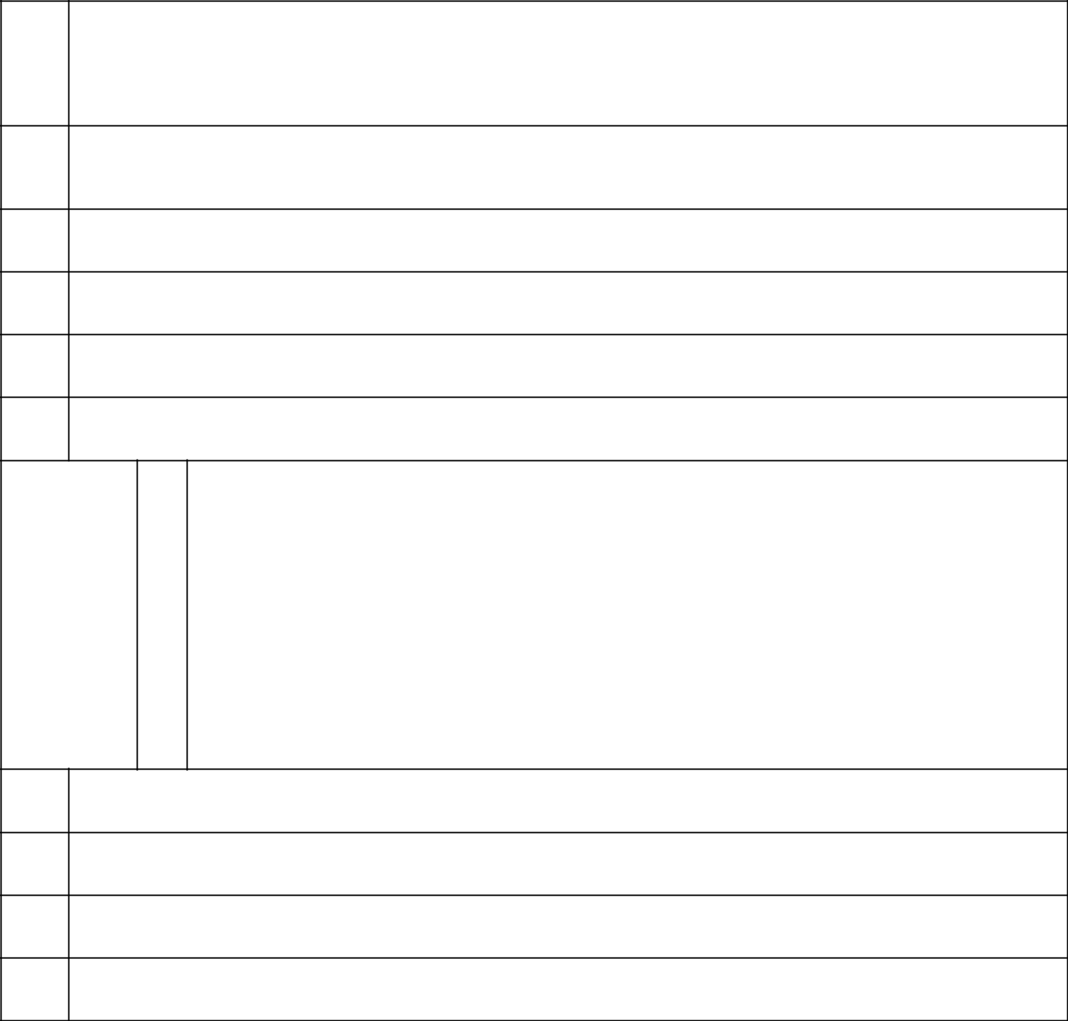

- CHECK THE APPROPRIATE BOX IF A MEMBER OF A GROUP*

  - [ ]

  - [ ]

- SEC USE ONLY

- SOURCE OF FUNDS (See Instructions)

WC/OO

- CHECK IF DISCLOSURE OF LEGAL PROCEEDINGS IS REQUIRED PURSUANT TO ITEMS 2(D) OR 2(E)

[ ]

- CITIZENSHIP OR PLACE OF ORGANIZATION

USA

NUMBER OF | 7 | SOLE VOTING POWER*
SHARES |  | 1,667,034
BENEFICIALLY | 8 | SHARED VOTING POWER
OWNED BY |  | 0
EACH | 9 | SOLE DISPOSITIVE POWER*
REPORTING |  | 1,667,034
PERSON | 10 | SHARED DISPOSITIVE POWER

WITH ⁰
- AGGREGATE AMOUNT BENEFICIALLY OWNED BY EACH REPORTING PERSON 1,667,034

- CHECK BOX IF THE AGGREGATE AMOUNT IN ROW (11) EXCLUDES CERTAIN SHARES (See Instructions)

[ ]

- PERCENT OF CLASS REPRESENTED BY AMOUNT IN ROW (11) 10.70%
- TYPE OF REPORTING PERSON (See Instructions)

IA

Page 2

*Based on information set forth on the Form 10-Q of Build-A-Bear Workshop, Inc. (the "Company", "Registrant", or "BBW") as filed with the Securities and Exchange Commission on June 10, 2022, there were 15,586,751 shares of Common Stock with par value $0.01 (the "Shares"), of the Company issued and outstanding as of June 7, 2022.

As of August 25, 2022 (the "Reporting Date"), Tristan Partners, L.P. ("Tristan"), the Tristan Offshore Fund Ltd. ("Tristan Offshore"), Tonga Partners, L.P. ("Tonga") and sundry Separately Managed Accounts ("SMAs") and collectively with Tristan and Tristan Offshore and Tonga (the "Investment Vehicles"), held in the aggregate 1,667,034 Shares.

Cannell Capital LLC acts as the investment adviser to Tonga, Tristan, Tristan Offshore and the SMAs. Mr. J. Carlo Cannell is the sole managing member of Cannell Capital LLC. The Reporting Person possesses the sole power to vote and to direct the disposition of the Shares held by the Investment Vehicles.

CUSIP No. | 120076104

- NAMES OF REPORTING PERSONS

I.R.S. IDENTIFICATION NOS. OF ABOVE PERSONS (ENTITIES ONLY) J. Carlo Cannell


- CHECK THE APPROPRIATE BOX IF A MEMBER OF A GROUP*

  - [ ]

  - [ ]

- SEC USE ONLY

- SOURCE OF FUNDS (See Instructions)

WC/OO

- CHECK IF DISCLOSURE OF LEGAL PROCEEDINGS IS REQUIRED PURSUANT TO ITEMS 2(D) OR 2(E)

[ ]

- CITIZENSHIP OR PLACE OF ORGANIZATION

USA

NUMBER OF | 7 | SOLE VOTING POWER*
SHARES |  | 1,667,034
BENEFICIALLY | 8 | SHARED VOTING POWER
OWNED BY |  | 0
EACH | 9 | SOLE DISPOSITIVE POWER*
REPORTING |  | 1,667,034
PERSON | 10 | SHARED DISPOSITIVE POWER

WITH ⁰
- AGGREGATE AMOUNT BENEFICIALLY OWNED BY EACH REPORTING PERSON 1,667,034

- CHECK BOX IF THE AGGREGATE AMOUNT IN ROW (11) EXCLUDES CERTAIN SHARES (See Instructions)

[ ]

- PERCENT OF CLASS REPRESENTED BY AMOUNT IN ROW (11) 10.70%
- TYPE OF REPORTING PERSON (See Instructions)

IN

Page 3

*Based on information set forth on the Form 10-Q of Build-A-Bear Workshop, Inc. (the "Company", "Registrant", or "BBW") as filed with the Securities and Exchange Commission on June 10, 2022, there were 15,586,751 shares of Common Stock with par value $0.01 (the "Shares"), of the Company issued and outstanding as of June 7, 2022.

As of August 25, 2022 (the "Reporting Date"), Tristan Partners, L.P. ("Tristan"), the Tristan Offshore Fund Ltd. ("Tristan Offshore"), Tonga Partners, L.P. ("Tonga") and sundry Separately Managed Accounts ("SMAs") and collectively with Tristan and Tristan Offshore and Tonga (the "Investment Vehicles"), held in the aggregate 1,667,034 Shares.

Cannell Capital LLC acts as the investment adviser to Tonga, Tristan, Tristan Offshore and the SMAs. Mr. J. Carlo Cannell is the sole managing member of Cannell Capital LLC. The Reporting Person possesses the sole power to vote and to direct the disposition of the Shares held by the Investment Vehicles.

Page 4

Item 1. Security and Issuer

The title of the class of equity securities to which this Schedule 13D relates is the Common Stock par value $0.01 per share of Build-A-Bear Workshop, Inc., a Delaware corporation.

The address of the principal executive offices of the Company is 415 South 18th Street, Saint Louis, MO 63103.

Item 2. Identity and Background

a) The name of the Reporting Person is J. Carlo Cannell (the "Reporting Person").

The Reporting Person is the sole managing member of Cannell Capital LLC, an investment adviser to the following entities:

Tristan Partners, L.P.

Tristan Offshore Fund, Ltd.
Tonga Partners, L.P.

Separately Managed Accounts

Set forth in the attached Annex "A" and incorporated herein by reference is a listing of the directors, general partners, managing members and controlling persons of the Reporting Person and the Investment Vehicles (collectively, the "Covered Persons"), and sets forth the principal occupation, citizenship and principal place of business of each Covered Person.

- The principal business address of the Reporting Person is:

245 Meriwether Circle Alta, WY 83414

- The principal business of the Reporting Person is the performance of investment management and advisory services. The principal business of the Investment Vehicles is investment in securities.

- Neither the Reporting Person, nor to the best of its knowledge, any of the Investment Vehicles, has, in the last five years, been convicted in a criminal proceeding (excluding traffic violations or similar misdemeanors).

- Neither the Reporting Person, nor to the best of its knowledge, any of the Investment Vehicles, has, during the last five years, been a party to a civil proceeding of a judicial or administrative body of competent jurisdiction and as a result of such proceeding was or is subject to a judgement, decree or final order enjoining future violations of, or prohibiting or mandating activities subject to, federal or state securities laws or finding any violations with respect to such laws.

- The place of organization of the Reporting Person is as follows:

Page 5

The citizenship of each Covered Person is set forth on the attached Annex A and incorporated herein by reference.

Mr. J. Carlo Cannell is the Managing Member of Cannell Capital LLC, a Wyoming limited liability company.

Item 3. Source and Amount of Funds or Other Considerations

The securities to which this statement relates were acquired by the Reporting Person using the working capital of each

Investment Vehicle as follows:
Tristan Partners, L.P.: $4,901,989
Tristan Offshore Fund, Ltd.: $2,157,114
Tonga Partners, L.P.: $1,997,475

Separately Managed Accounts: $2,616,518

The Investment Vehicles have invested an aggregate amount of approximately $11,673,096 in the Shares. Item 4. Purpose of Transaction

Cannell Capital LLC, on behalf of the Investment Vehicles, identified the Company as an entity satisfying each of the Investment Vehicle's investment criteria. The Investment Vehicles acquired these shares in the ordinary course of business and not with the intent to change or influence control of the Company. The Investment Vehicles continue to hold the Shares as a long-term investment.

Mr. Cannell makes this filing to disclose a letter to the Board of Directors of the Company attached as Exhibit 99. Depending on various factors including, without limitation, the Company's financial position and investment strategy, the price levels of the Shares, conditions in the securities markets and general economic and industry conditions, Mr. Cannell may in the future take such actions with respect to their investment in the Company as they deem appropriate including, without limitation, engaging in communications with management and the Board of Directors of the Company, engaging in discussions with stockholders of the Company or other third parties about the Company and Mr. Cannell's investment, including potential business combinations or dispositions involving the Company or certain of its businesses, making recommendations or proposals to the Company concerning changes to the capitalization, ownership structure, board structure (including board composition), potential business combinations or dispositions involving the Company or certain of its businesses, or suggestions for improving the Company's financial and/or operational performance, purchasing additional Shares, selling some or all of their Shares, engaging in short selling of or any hedging or similar transaction with respect to the Shares, including swaps and other derivative instruments, or changing their intention with respect to any and all matters referred to in Item 4.

Page 6

Item 5. Interest in Securities of the Issuer

Based on information set forth on the Form 10-Q of Build-A-Bear Workshop, Inc. (the "Company", "Registrant", or "BBW") as filed with the Securities and Exchange Commission on June 9, 2022, there were 15,586,751 shares of Common Stock with par value $0.01 (the "Shares"), of the Company issued and outstanding as of June 7, 2022.

- As of August 25, 2022, for the purposes of Reg. Section 240.13d-3, Cannell Capital LLC may be deemed to beneficially own 1,667,034 Shares, or approximately 10.70% of the Shares deemed issued and outstanding as of the Reporting Date.

- Cannell Capital LLC possesses the sole power to vote and to direct the disposition of the Shares held by the Investment Vehicles.

- The following table details the transactions during the sixty days on or prior to the Reporting Date in Shares, or securities convertible into, exercisable for or exchangeable for Shares, by Cannell Capital LLC or any other person or entity controlled by him or any person or entity for which he possesses voting or investment control over the securities thereof (each of which was effected in an ordinary brokerage transaction by Cannell Capital LLC on behalf of the Investment Vehicles).

None.

Item 6. Contracts, Arrangements, Understandings or Relationships with Respect to Securities of the Issuer

None.

Item 7. Material to Be Filed as Exhibits

Exhibit 99 August 25 letter from Mr. J. Carlo Cannell of Cannell Capital LLC to the Board of Directors of Build-A-Bear Workshop, Inc.

Signature

After reasonable inquiry and to the best of my knowledge and belief, I certify that the information set forth in this statement is true, complete and correct.

August 25, 2022

Dated

/s/ J. Carlo Cannell

Signature

J. Carlo Cannell, Managing Member

Name/Title

Page 7

The original statement shall be signed by each person on whose behalf the statement is filed or his authorized representative. If the statement is signed on behalf of a person by his authorized representative (other than an executive officer or general partner of this filing person), evidence of the representative's authority to sign on behalf of such person shall be filed with the statement, provided, however, that a power of attorney for this purpose which is already on file with the Commission may be incorporated by reference. The name and any title of each person who signs the statement shall be typed or printed beneath his signature.

Attention: Intentional misstatements or omissions of fact constitute Federal criminal violations (See 18 U.S.C. 1001).

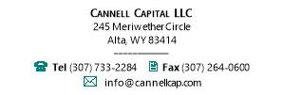

August 25, 2022

Board of Directors

Build-A-Bear Workshop, Inc.
415 South 18th Street

Saint Louis, MO 63103

Dear Directors:

Cannell Capital LLC ("CC"), the largest shareholder of Build-A-Bear Workshop, Inc. ("BBW" or the "Company") as of June 30, 2022, believes that BBW enjoys an ahistorical opportunity to add value for owners through a tender of its own stock and on July 21 demanded such.

On July 22, BBW requested a reasonable amount of time to ruminate upon this demand. CC has waited 34 days. Now CC makes its position public since BBW has taken no action.

Fig. 1: Deaf Ears at BBW. Get Greedy When Others Panic. BOD Clueless.
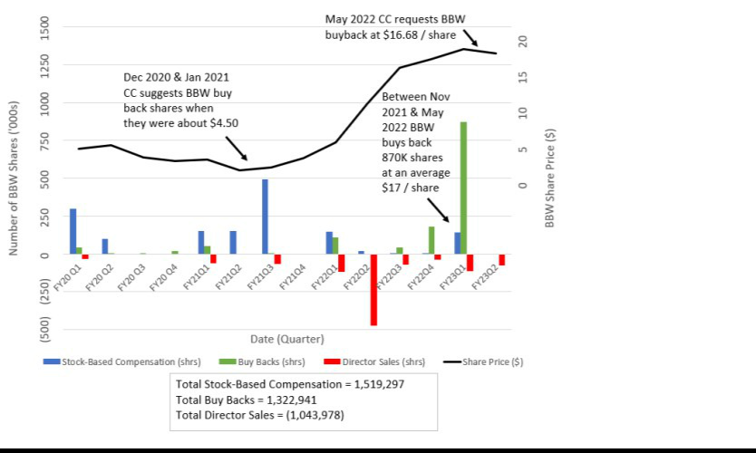

Please consider the following as part of this request.

The Company enjoys excess liquidity - $26 million of cash and no debt as of March 31, 2022 - and borrowing capacity of up to $25 million at about 5% interest (CC estimates). This arguable overcapitalization is increasing as BBW generated $20 million of free cash flow last year and CC expects our Company to generate at least $30 million more this year. Furthermore, BBW owns a 350,000 square-foot distribution center in Ohio that, if monetized via a sale leaseback transaction, would yield about $35 million.

BBW management may know how to manage stores, but the Board of Directors to whom management is supposed to report has done a poor job allocating owners' capital. See Figure 1.

The experience of CC is that when owners have little skin in the game - real skin which they buy and are not given - capital allocation resonates less. Officers and directors have bought little to no shares of BBW.

BBW is significantly under-leveraged relative to its mall-based specialty retailer peers. Bath & Body Works, Inc. (BBWI), for instance, carries net debt equal to 2x trailing twelve-month EBITDA.

Using sell-side consensus estimates, BBW's stock is trading at just 6x 2022 estimated EPS, its lowest level in about 18 years.

By our math, if BBW were to monetize its real estate assets and take net leverage to just 1x through a tender at $17 per share, 2022 earnings per share would grow 110% inclusive of incremental interest and leasing costs.

Fig. 2. BBW Buyback Calculus ($ million, FY Jan)

Net Leverage Target

Cash on hand FQ1 2022

Implied debt

Estimated proceeds from sale leaseback Purchasing power

Repurchase price

Shares repurchased (million)

- Total S/O repurchased PF S/O

Assumed Cost of Debt

CY consensus net income estimate Assumed incremental lease expense Interest expense

Tax benefit PF net income

PF Adjusted EPS

- Boost to Consensus EPS Earnings Yield %

0x | 0.5x | 1.0x
$26 | $26 | $26
25 | 61 | 96
35 | 35 | 35
$86 | $122 | $157
$16.75 | $16.75 | $16.75
5.1 | 7.3 | 9.4
33% | 47% | 60%
10.3 | 8.2 | 6.1
5.5% | 6.5% | 8.0%
43 | 43 | 43
(2) | (2) | (2)
(1) | (4) | (8)
1 | 1 | 2
$40 | $39 | $36
$3.92 | $4.70 | $5.85
41% | 69% | 110%
25% | 30% | 38%

- grows weary of BBW's poor capital allocation. As illustrated in Figure 1, CC has repeatedly advocated for buybacks only to see the lethargic Board buy back shares at prices 255% to 274% higher than when its largest owner advocated.

On July 21 CC talked to BBW and urged its Board of Directors to conduct a modified Dutch tender for BBW's common stock.

- agreed to give BBW more time in which to arrange the legal and compliance groundwork for such an offer. BBW management's inaction has left CC with no option but to release this letter and with it our decisive vote of "no confidence" in the Board. All owners of BBW should consider whether new directors wouldn't be better stewards of our Company.

Best regards!

Sincerely,

/s/ J. Carlo Cannell

J. Carlo Cannell
Managing Member

